Batch: D2 Roll No.: 25

Experiment / assignment / tutorial No. 5

Grade: AA / AB / BB / BC / CC / CD /DD

Signature of the Staff In-charge with date

TITLE: Program to sort array

Expected OUTCOME of Experiment:
AIM: Program to sort the 1D array in the ascending or descending order and then accept the element from user and insert in the same array at its correct place by keeping array sorted ______________________________________________________________________

_____________________________________________________________________
Books/ Journals/ Websites referred:

- Programming in C, second edition, Pradeep Dey and Manas Ghosh, Oxford University Press.
- Programming in ANSI C, fifth edition, E Balagurusamy, Tata McGraw Hill.
- Introduction to programming and problem solving, G. Michael Schneider ,Wiley India edition.
- http://cse.iitkgp.ac.in/~rkumar/pds-vlab/

_____________________________________________________________________

Problem Definition:

The program takes a 1D array and sorts it in the specified manner. The user enters an element and the same has to be inserted at the correct place in the sorted array.

Flowchart:
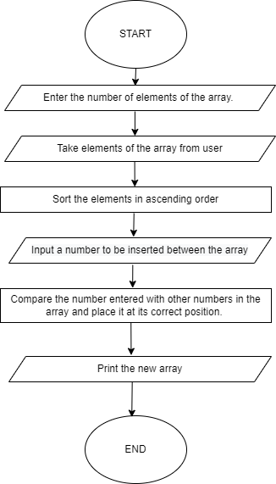

Implementation details:

Input a number from user and create a array of that size. Input the elements of array from user and sort in ascending order using selection sort/ bubble sort. Then input a number from user and insert it at the appropriate location so that the ascending order doesn’t get disturb.

Output(s):
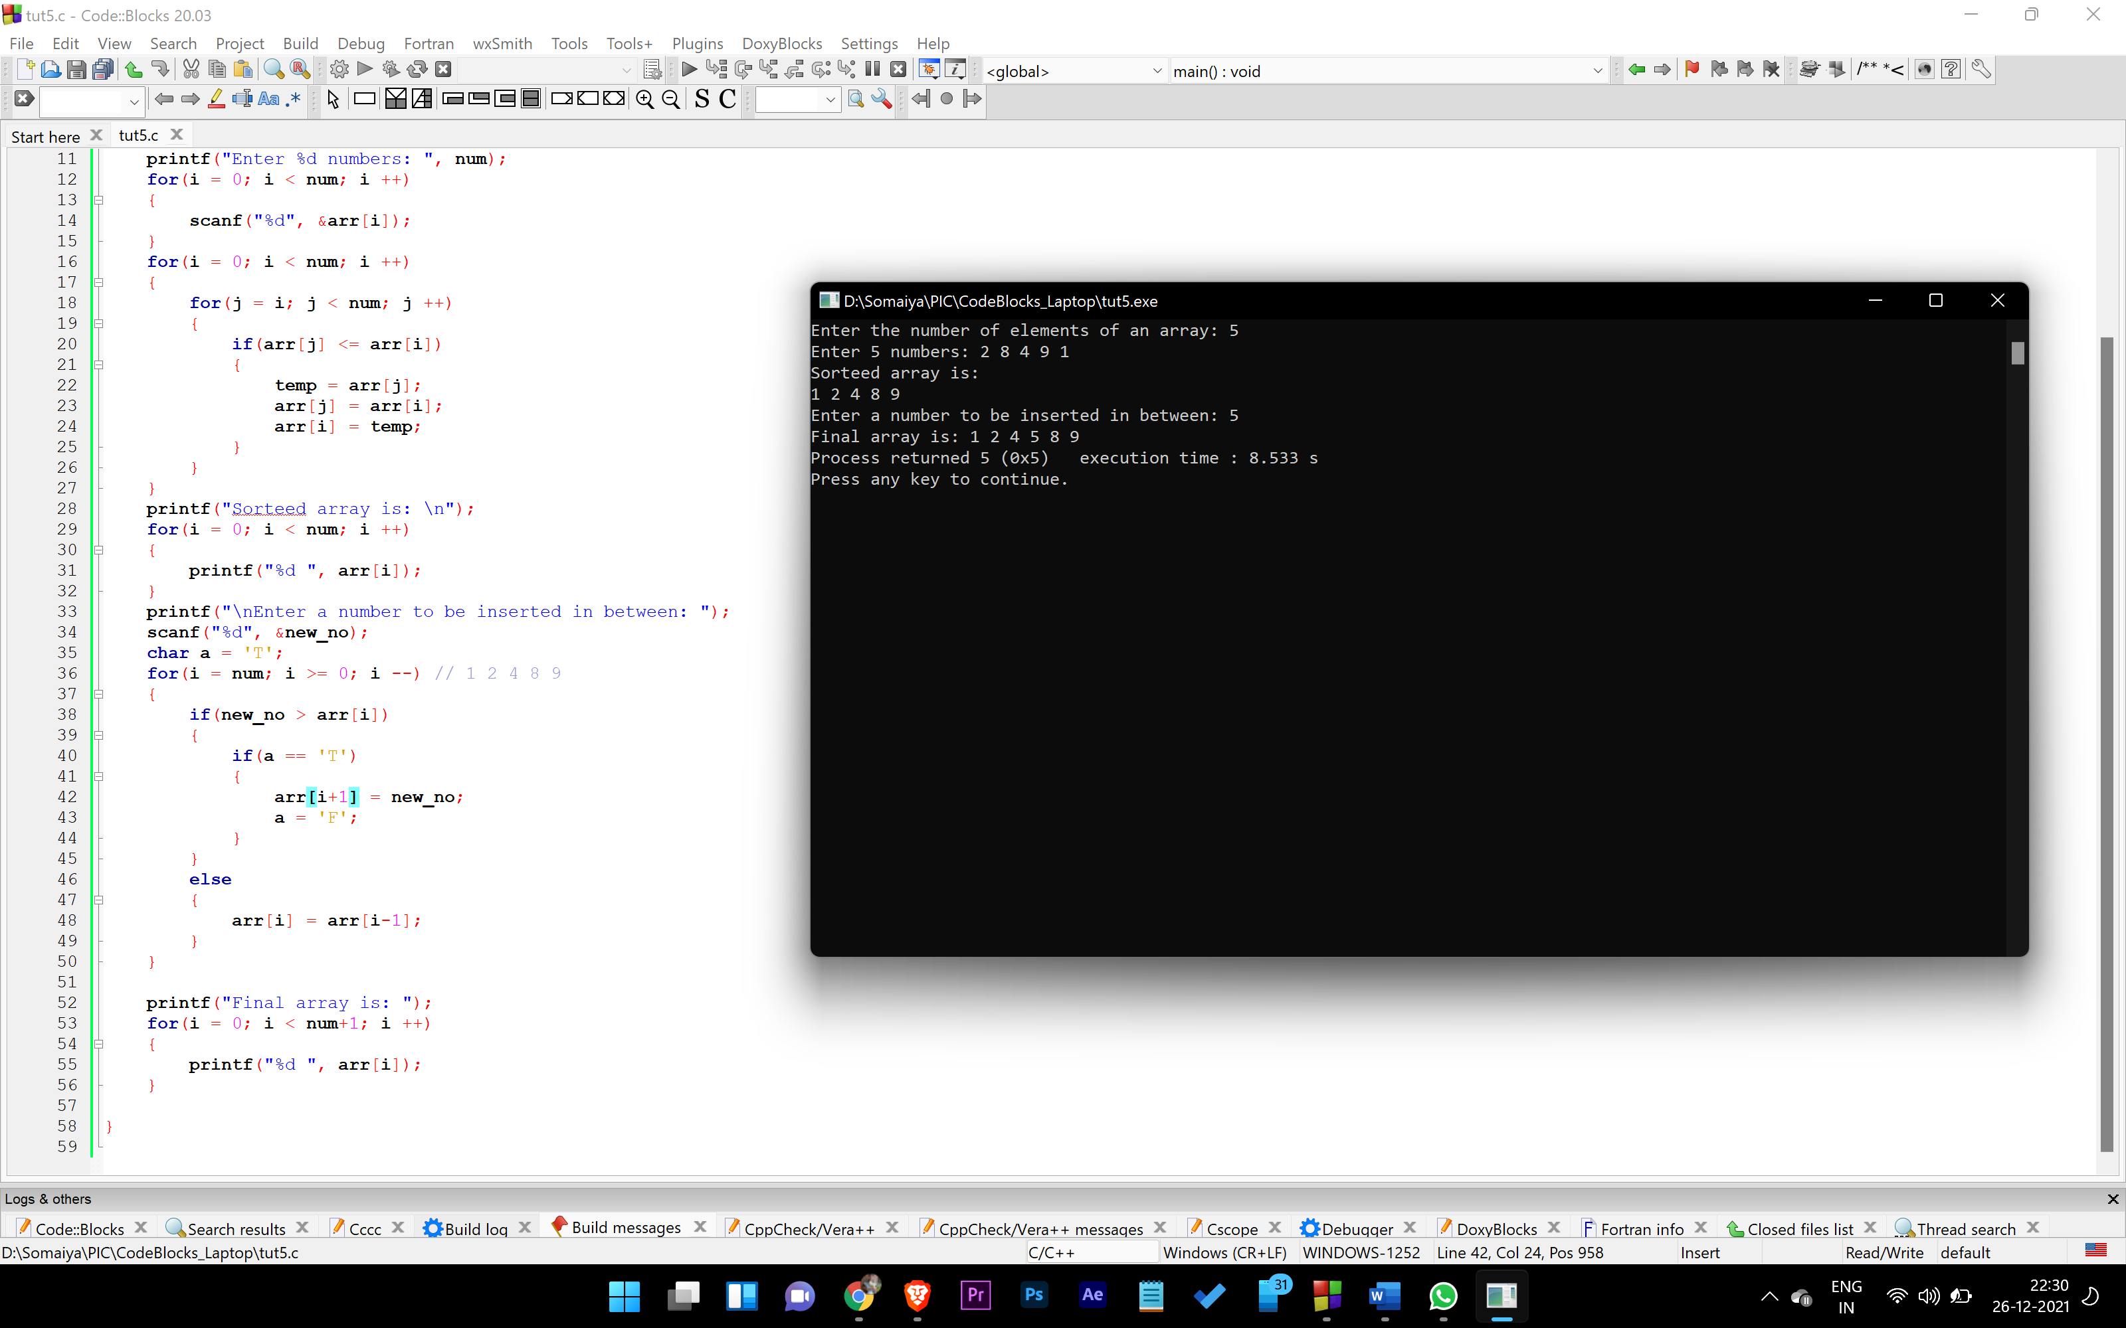

Conclusion: We learn how to sort array and insert a new number inside an array.

Post Lab Descriptive Questions

Write a program to enter n numbers, store them in an array and rearrange array in the reverse order.

Date: _____________ Signature of faculty in-charge

